PE Definition Document

Description: A highly efficient, instruction-set driven Processing Element (PE) for accelerating quantized neural network inference.

PE Operation

The PE operates as an instruction-driven hardware accelerator designed to offload computationally intensive neural network inference tasks. Controlled by a Chip Select signal, the PE transitions between a no-operation state and an active execution mode. The PE operates on quantized signed integers, which serve as efficient approximations of the original floating-point number model parameters. When enabled and valid, the internal controller samples the operation code and the inputs data busses, causing activity in the following clock cycle.

Following the input validity signal, two registers ingest signed 32-bit packed integer operands, typically representing neural network inputs and weights. The PE can dynamically reconfigure its arithmetic core to support high-fidelity INT8 operations, high-throughput INT4 operations, or a full 32x32 multi-cycle scalar multiplication.
The computational datapath executes operations sequentially. It first performs a series of Multiply and Accumulate (MAC) operations to collect partial sums, followed by a full 32x32 multiplication to finalize the arithmetic phase into the 64-bit register. Once all math operations are complete, a dedicated Requantizer module shifts the massive 64-bit signed accumulator value down to an 8-bit signed integer. A hardware-based activation function then processes this scaled value to finalize the inference result. This final activation output is driven to the output bus, which is synchronized with an output_valid signal to ensure seamless and accurate integration with the host system.

Power-Up State: The power-up state of the PE is undefined; For a cleared state at power-up, the user must activate the System Reset signal.
System Reset: A synchronous, active-low System Reset input signal clears all internal registers and initializes the datapath to a default idle state with a zeroed accumulator.

ISA (Instruction Set Architecture)

Op-Code Table

Op-Code | Mnemonic | Full Name | Description
00000 | NOP | No Operation | The controller takes no action. All datapath modules hold their current state and wait.
00001 | RST_ACC | Reset Accumulator | Clears the 64-bit signed accumulator register to zero.
00010 | MAC4 | Multiply and Accumulate in INT4 | PE treats the 32-bit inputs as eight 4-bit signed integers.
00011 | MAC8 | Multiply and Accumulate in INT8 | PE treats the 32-bit inputs as four 8-bit signed integers.
00100 | ADD_BIAS | Add Bias | Adds the 32-bit bias to the accumulator from the operand_B bus.
00101 | MULT32 | 32x32 Multiplication | Triggers a 4-cycle multiplication.
00110 | SHIFT_RIGHT | Shift Right (Requantize) | Requantizes the 64-bit accumulator down to an 8-bit value. The 6-bit shift amount is read directly from operand_A[5:0].
00111 | APPLY_ACT | Apply Activation | Applies an activation function to the scaled 8-bit value.
01000- 11111 | RSV | Reserved | Reserved for future instruction expansion.
Table 1. Op-Codes

Instructions Breakdown

- RST_ACC: This instruction clears the accumulator. No operands are required on the data buses for the execution of this instruction.
- MAC8 vs MAC4 Operation: The MAC instructions perform a parallel dot-product on the operand_A and operand_B inputs. The MAC8 instruction configures the datapath for INT8 precision. The 32-bit buses are interpreted as four packed, signed 8-bit integers, which are multiplied in parallel, then added into a 64-bit accumulator. The MAC4 instruction configures the datapath for INT4 precision. The 32-bit buses are interpreted as eight packed, signed 4-bit integers, which are multiplied in parallel as well, then added to the accumulator.
- MULT32: This instruction initiates a full 32x32 signed multiplication over four clock cycles. The hardware calculates the result by multiplying the full 32-bit operand_A by one byte of operand_B per cycle. The PE Controller automatically manages the system stall during this multi-cycle operation.
- ADD_BIAS: Bypasses the multiplier array completely. The 32-bit value on the operand_B bus is sign-extended and added directly to the current 64-bit accumulator sum.
- SHIFT_RIGHT: The controller pulses the Requantizer module to scale the 64-bit accumulator value down to an 8-bit integer. During the exact clock cycle that this opcode is issued, the lower 6-bits of operand_A 32-bit bus (operand_A[5:0]) serve as a 6-bit shift amount. The hardware uses this immediate value to perform the arithmetic right-shift.
- APPLY_ACT: Applying an activation function to the activation input. The unit maps the rescaled 8-bit data into a final non-linear output value.

I/O Interface

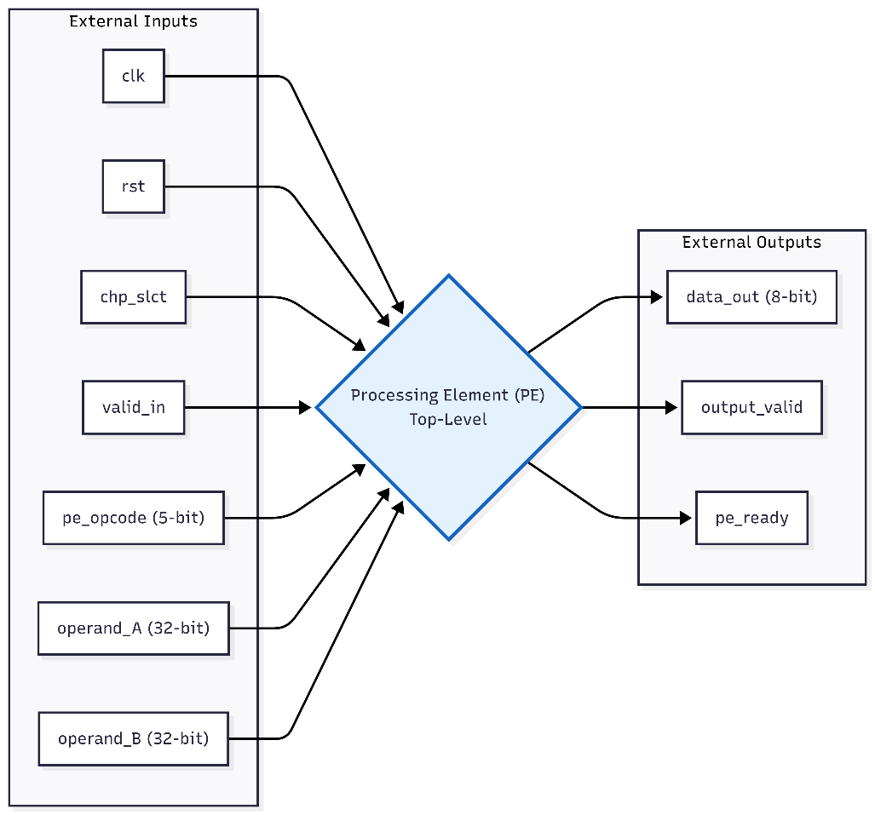

Figure 1. PE Top-Level Interface

The following table defines the top-level input and output ports of the Processing Element. All signals are sampled on the rising edge of the main system clock.

Signal Name | Signal Type | Width | Direction | Function | User Note
clk | Global | 1 bit | Input | System Clock | Main system clock.
rst | Global | 1 bit | Input | System Reset | Active-low asynchronous reset. Clears all internal registers and initializes the datapath.
chp_slct | Control | 1 bit | Input | Chip Select | When inactive, operands and instructions are not sampled. Operations started before inactivity continue until end.
input_valid | Control | 1 bit | Input | Input Validity | Signals that the data on the input buses is valid and should be sampled.
pe_opcode | Control | 5-bit bus | Input | Operational Code | The global instruction routed to the PE Controller to dictate the current datapath operation.
operand_A | Data | 32-bit bus | Input | NN Inputs / Weights /  Shift Amount | Packed integer data bus. Contains four signed INT8s, eight INT4s, or a 6-bit shift amount (shamt) during a SHIFT_RIGHT instruction.
operand_B | Data | 32-bit bus | Input | NN Inputs / Weights / Bias / Scaling Factor | Packed integer data bus. Contains four signed INT8s, eight INT4s, or a 32-bit scalar/bias.
data_out | Data | 8-bit bus | Output | NN Output | The final 8-bit quantized inference result driven by the Activation block.
output_valid | Global | 1 bit | Output | Output Validity | Asserted high for one clock cycle following an activation instruction, indicating the data on data_out is a valid, finished result.
pe_ready | Control | 1 bit | Output | Ready Flag | Flow-control flag. When high, the PE is idle and ready to accept new instructions. When low, the PE is stalled executing a multi-cycle operation.
Table 2. I/O

